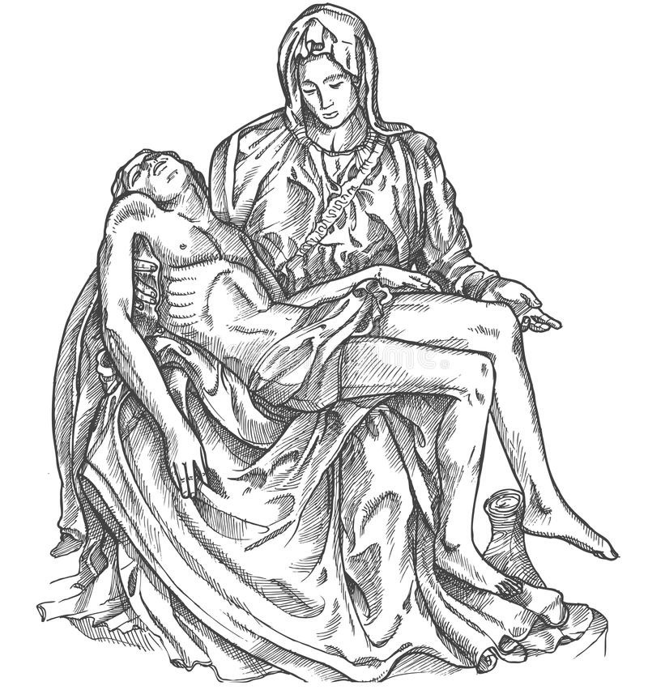
The Confraternity of Christian Mothers
Mater Dolorosa, ora pro nobis!
WELCOME PACKET
TABLE OF CONTENTS

Introduction ……………………………………………………………………………………………………………………………………. 3

Origin & Object of the Confraternity………………………………………………………………………………………………… 4

Membership in the Confraternity…………………………………………………………………………………………………….. 5

Transferring Membership………………………………………………………………………………………………………………… 6

Indulgences …………………………………………………………………………………………………………………………………….. 7

Bylaws of the Confraternity of Christian Mothers of (Name of your parish) ………..….………………………. 9

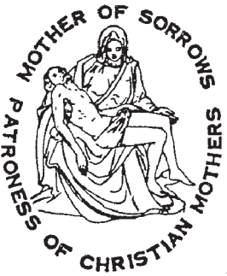 | The Confraternity of Christian Mothers  of (name of your parish)

Greetings!

Thank you for your interest in the Confraternity of Christian Mothers! We meet (when you plan to meet) (unless otherwise indicated in the bulletin) for Holy Mass, community prayers, a spiritual conference by Canon, and social time. Solemn receptions are held (If you want to specify this). Those interested in the Confraternity are welcome to join monthly meetings to discern whether they would like to enroll. Please read through this Welcome Packet to answer some general questions about the Confraternity. You may reach out to the Officers at (give a contact email) with any additional questions.

Our Lady of Sorrows, pray for us!

Origin

What strikes us particularly about the origin of the Christian Mothers’ Confraternity is that it was so spontaneous. It was not something that was foisted upon Catholic women, but something that grew out of themselves. It was one of those providential movements of the lay apostolate by which the Holy Spirit so often renews the spirit of the Church or of some group within the Church

It was at a time, in the middle of the 19th century, when the modern forces undermining family life first began to lift their heads, that the Christian Mothers reacted in a spiritual and spiritualizing movement. It was a movement of self-defense and self-preservation.

In various parts of France, and especially in Lille, mothers began to gather to pray with and for one another, and their children, to discuss their problems and to advise one another regarding the Christian rearing of their children.

The movement gradually solidified, and on May 1, 1850, the first conference of Christian Mothers was held in Lille, France, under the leadership of Louise Josson de Bilhem, the wife of a court official. The mothers sought and found recognition from the bishop for their growing organization. Once that approval was given, the organization grew by leaps and bounds, throughout France and the neighboring countries, and soon over a million women were enrolled as members.

At present there are six Archconfraternity of Christian Mothers in the world. They are located in Paris, Rome, Regensburg (Ratisbon), Cracow, Einsiedeln, and Pittsburgh. The society found its way to America at an early date, and on the 16th of January, 1881, the Confraternity of Christian Mothers canonically erected in St. Augustine’s Church (now known as Our Lady of the Angels Parish), 220-37th St., Pittsburgh, PA., was raised to the rank of an Archconfraternity with the right of affiliating other Confraternities wherever the Ordinary approved.

Since then over 3,400 Confraternities have been affiliated with the Pittsburgh Archconfraternity directed by the Capuchin Friars.

Object

The Confraternity of Christian Mothers has for its object the Christian home education of children by truly Christian Mothers. It plans to unite by the observance of its rules and regulations all Christian ladies, married or widowed, who are willing to assist one another to attain this noble purpose. Under the special patronage of the “Mother of Sorrows” the members are encouraged joyously and hopefully to undertake the important task of training and sanctifying the young souls entrusted to their care. They are schooled to edify one another by word and deed, to support one another by fervent prayer and thus become the mainstay of spiritual life within their own family, and a fruitful source of blessing to the community in which they live. This is the principal aim of all Confraternities affiliated with the Archconfraternity.
Membership in the Confraternity of Christian Mothers

Becoming a Member
- Who is Eligible?
  - "Any Catholic mother regularly attending Mass at (name your parish) shall be eligible for full membership. Any Catholic woman, who is not a mother, may join as an associate member." (From the Bylaws of the Confraternity of Christian Mothers of your parish)
- How to Become a Member
  - Attend meetings to discern if you wish to enroll as a member.
  - Enrollment in the Confraternity occurs two times a year in May and September through a Solemn Reception Ceremony.
  - Upon enrollment, one’s name is recorded in the register of members.
  - Pay a one-time enrollment fee to cover the cost of items given to each newly enrolled member.
- During the Solemn Reception Ceremony an Act of Consecration to Mary will be recited by the ladies to be enrolled. Father Director, will also ask the following questions:
  - Do you consecrate yourselves and your children from the bottom of your hearts to the Blessed Virgin Mary, the Mother of Sorrows?
  - Will you honor and love her as your Mother, and instill the same affection into the hearts of your children?
  - Will you be truly Christian Mothers and try to make your children faithful members of the Catholic Church and followers of Jesus Christ? Will you pray for them and make every sacrifice God may demand of you for the salvation of their souls?

Duties of Members
- Pay annual dues
- Pray the Daily Prayer for Children
- Participate in monthly gatherings. This includes attending Mass, community prayers, a business meeting, a conference by Father Director, and social time.
  - It is understandable that one may not be able to attend every meeting due to one’s season in life; for example, a family illness or a new baby.
- Pray for other members of the local Confraternity, as well as other members associated with Archconfraternity in Pittsburgh and those worldwide.
- Use the Mother Love book as part of one’s own spiritual enrichment.

Benefits of Membership
- Spiritual:
  - Mass is offered for members throughout the year and upon their death.
  - Prayers from members worldwide
  - Opportunity to gain plenary indulgences
- Intellectual
  - Monthly conference from Father Director. Example topics include the virtues, prayer, and motherhood.
  - Access to the Confraternity “store,” which includes the Mother Love book
- Social:
  - Social time is provided at the end of each monthly meeting. Be encouraged in the faith, motherhood, family life, and build friendship.

Transferring Membership

From the Manual for Directors and Officers:

“A public and solemn reception is no longer required, yet it can hardly be dispensed with.” (p. 28)

“At the reception, each woman should receive a Christian Mother Medal, the Conference Booklet of prayers, and a separate Daily Prayer card . …A Certificate of Membership is given to each member. …” (p.28)

“Members transferring to another Confraternity need only present themselves to the Father Director in their new parish and mention their membership so that he may place their names on the Confraternity register.” (p. 29)

“The Canon Law of the Church requires accurate registration of the names of the members in a well-bound book for the validity of membership.” (p.75)

From the Bylaws of (name your parish) Confraternity:

“Those members paying yearly dues will be considered active members in the Confraternity and will be recorded in the official register sent to the National Office.” (Article V, III)

“An induction fee of $30 shall be paid upon enrollment into the Confraternity to cover the cost of the medal of the Sorrowful Mother, Handbook for Members, certificate of membership, and daily prayer card.” (Article XII)

“Dues of $10 shall be paid upon enrollment into the Confraternity and annually thereafter.” (Article XII)

If you were enrolled at another Confraternity (i.e., your name was signed in the Confraternity’s Register of Members), you may sign your name in the parish Register of Members for accurate registration of your transferred membership. Please contact Lady Secretary to find an agreeable time. Annual dues will be collected upon transfer of membership and annually thereafter. Additionally, all ladies of the Confraternity should have a Sorrowful Mother medal, Handbook for Members, and daily prayer card. If any lady transferring her membership does not have these items, they can be purchased from Lady Treasurer at the time dues are paid. All new medals purchased should be blessed by Father Director.

If you participated in a Confraternity previously but have not yet been enrolled, you may enroll in the Confraternity during the Solemn Reception Ceremony held (preference of your pastor/director in dialogue with the officers). This is not considered a transfer of membership but an enrollment. Any questions or clarifications may be directed to Lady President.

INDULGENCES

Plenary Indulgences

(The following letter explains why there has been a change
regarding the indulgenced feast days.)

The Sacred Apostolic Penitentiary, Rome, Italy.

Most Holy Father:

The spiritual director of the Archconfraternity of Christian Mothers, established in Saint Augustine Church of the Order of Friars Minor Capuchin, of the Episcopal city of Pittsburgh, humbly asks that, according to the norm of the Apostolic Constitution “The Doctrine and Practice of Indulgences” of January 1, 1967, n. 14, the Indulgences granted by the Holy See to the aforesaid Archconfraternity be reviewed.

January 17, 1968

The Sacred Penitentiary, by special and express Apostolic Authority, graciously grants a plenary indulgence to be gained by the aforesaid members, provided they fulfill the usual conditions (confession, communion and prayer for the intention of the Holy Father) and make or renew, at least privately, their promise faithfully to observe the rules of the association.
- On the day of solemn reception.

- On the feasts of:
  - Holy Family -- Sunday within the Octave of the Nativity
  - Annunciation -- March 25
  - Queenship of Mary -- August 22
  - Our Lady of Sorrows -- September 15
  - St. Gerard Majella -- October 16
  - Christ the King -- Last Sunday After Pentecost
  - St. Elizabeth -- Mother of St. John the Baptist -- November 5

Partial Indulgences

- On four days appointed by the Director. Conditions: Prayer according to the intentions of the Holy Father. [St. Joseph (March 19), St. Monica (May 4), St. Anne (July 26), and the Holy Guardian Angels (October 2)] (others can be added or some changed)

- As often as members are present at the Conference and lectures

- For the recitation with a contrite heart of the Christian Mother’s Daily Prayer for the Children.

- For every good work performed according to the object and rules of the Confraternity or on its behalf.

Some Norms from the Apostolic Constitution on Indulgences:

No. 2 - An Indulgence is either plenary or partial accordingly as it frees a person either in whole or in part from the temporal punishment due to sins.

No. 6 - A plenary indulgence may be gained only once in any day. A partial indulgence may be gained many times a day, unless something different is explicitly stated.

No. 7 - The requirements for gaining a plenary indulgence are the performance of the indulgenced work and fulfillment of three conditions: sacramental confession; eucharistic communion; prayer for the Pope’s intentions. A further requirement is the exclusion of all attachment to sin, even venial sin.

No. 8 - The three conditions may be carried out several days preceding or following performance of the prescribed work. But it is more fitting that the communion and the prayer for the Pope’s intentions take place on the day this work is performed.

No. 9 - Several plenary indulgences may be gained on the basis of a single sacramental confession; only one may be gained, however, on the basis of a single eucharistic communion and prayer for the Pope’s intentions.

No. 10 - The condition requiring prayer for the Pope’s intentions is completely satisfied by reciting once the Our Father and Hail Mary for his intentions; nevertheless, all the faithful have the option of reciting any other prayer suited to their own devotion and the reverence for the Pope.

Bylaws of:

The Confraternity of Christian Mothers of (name your parish)

(City, state and Diocese of your parish)

Article I: Name

The name of the society shall be The Confraternity of Christian Mothers of (name your parish).

Article II: Patroness

The patroness of this society shall be the Immaculate Virgin under the title of Our Lady of Sorrows.

Article III: Mission

The mission of the Confraternity of Christian Mothers of (name your parish) is to assist Catholic women in living faithfully their vocation of motherhood, taking as their model Mother Mary, Our Lady of Sorrows. Desirous of fostering growth in the spiritual life and forming a truly Christian community, members seek to sanctify themselves and their families through prayer, words, and deeds.

Article IV: Father Director

As (name your parish) is in the (Diocese/ Archdiocese of ______) the canonically erected Pastor, or the priest whom he delegates, shall serve as Father Director.

Article V: Membership

- Any Catholic mother regularly attending Mass at (name your parish) shall be eligible for full membership. Any Catholic woman, who is not a mother, may join as an associate member. Non-Catholic women interested in learning more about the Catholic faith are welcome to attend meetings and events.
- The reception of new members will be held (at your discretion with your director).

- Those members paying yearly dues will be considered active members in the Confraternity and will be recorded in the official register sent to the National Office.
Article VI: Duties of Members
- Pray the Daily Prayer for the Children, and use the Mother Love prayer book as part of their personal spiritual formation.

- Attend the monthly meetings, whenever possible.

- Pay the annual dues.

- Participate in the activities of the Confraternity as much as possible without compromising their other responsibilities.

- Pray for the other members (including deceased members), our Father Director, our National Executive Director, and any benefactors.

Article VII: Meetings

Whenever possible, regular meetings shall be held at the time and location designated appropriate by Father Director and the President. As needed, additional meetings may be scheduled by Father Director in conjunction with the President.

Article VIII: Officers

The officers of this society shall be president, vice-president, secretary, and treasurer.

- Elections: Officer elections shall take place (discretion of the Director and officers). Upon election of new officers, both current and newly elected officers shall meet to transition all business items.

- Nomination: Any active member may nominate another full, active member for an officer position. Any full, active member may also nominate herself for an officer position.
- Accepting Nomination: Those nominated must accept or decline the nomination at the meeting or in writing if the meeting cannot be attended prior to discussion and appointment.
- Selection: Officers shall be selected by a simple majority consensus of active members with the approval of the Father Director.
- Installation: Father Director shall appoint those selected.
- Terms: Each term is (discretion of your Director and officers). Any given officer may be re-elected into her current office or another office.

Article IX: Duties of Officers

- President:
  - Prepare an agenda for regular and executive meetings.
  - Preside over and maintain order at meetings.
  - Act as ex-officio member (by virtue of the office) of every committee.
  - Lead all aspects of communication for the Confraternity.
  - Act as liaison between the National Office and the local Confraternity. Includes sending the register of members to the National Office annually.
  - Serve as primary liaison between Father Director and the Confraternity.

- Vice-President:
  - Assist to create an agenda for meetings.
  - Preside at meetings in the absence of the president.
  - Take the title and duties of president for the unexpired term in case of
resignation or death of the president.
  - Chair committees as needed.
  - Help the president in any way she can.
- Secretary:
  - Assist to create an agenda for meetings.
  - Assist with necessary correspondence in liaison with the President.
  - Record the minutes at regular and executive meetings and distribute minutes to the relevant members after each meeting.
  - Keep the official copy of bylaws.
  - Keep the official register of members and update annually.
  - Maintain accurate records and act as historian.
  - Keep a copy of the Manual for Directors & Officers and the Hand Book for Officers.
- Treasurer:

  - Maintain accurate financial records and report quarterly to the Oratory bookkeeper.
  - Collect dues.
  - Purchase and maintain inventory of materials for the Confraternity, as needed.
  - Report at meetings quarterly.
  - Arrange Masses for the living and deceased members and for the Confraternity feast day.
Article X: Vacancy in Office

- President: If the office of president becomes vacant the vice-president automatically assumes the position.

- All Other Offices: In the case that any other office becomes vacant, the other officers, together with Father Director, shall determine if a special election is warranted or if the duties of the vacated office should be assumed by the other officers.

Article XI: Committees

- Executive Committee: The officers and Father Director will serve as the Executive Committee.

  - The Executive Committee shall meet at the beginning of every quarter to plan for the needs of the Confraternity in the coming months. Meetings can be canceled or rescheduled, as needed.
  - At one of the quarterly meetings, the Executive Committee shall review the 'Examination of Conscience for a Confraternity.'

- Other Committees: If the formation of additional committees is needed, the need shall be brought forth to the Executive Committee who shall determine if the committee should be created. The Executive Committee shall authorize and define the powers and duties of all other committees.

  - Membership: The president shall make appointments to committees with the approval of Father Director. Other officers should then be informed of committee members.
  - Listing of Committees and Members: The secretary shall maintain an official listing of committees, including leaders and members.

Article XII: Induction Fee and Annual Dues

An induction fee of (discretionary) shall be paid upon enrollment into the Confraternity to cover the cost of the medal of the Sorrowful Mother, Handbook for Members, certificate of membership, and daily prayer card.

Dues of (discretionary) shall be paid upon enrollment into the Confraternity and annually thereafter. Additional expenses may be necessary for purchasing materials or events, such as a Day of Recollection.

Article XIII: Amendments

These bylaws may be amended by the appointed officers with a majority vote and with approval of Father Director.

Originally Prepared:
Amended:

